3rd Grade
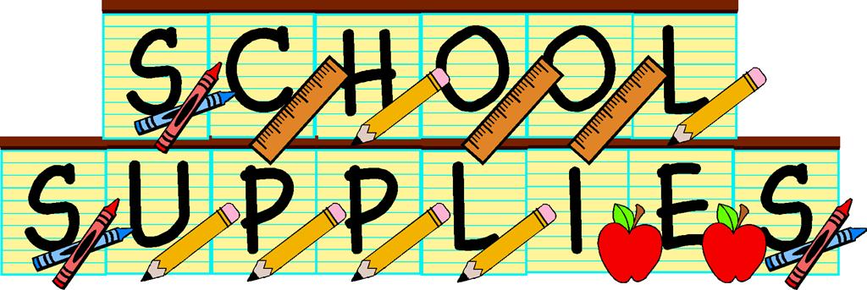
2025-2026

- 4 pocket folders: (One of each color: red, yellow, blue, green)
- Two hardcover marbled composition books – (Wide Ruled)
- 2 boxes of sharpened pencils
- erasers
- rounded tip scissors
- crayons (box of 24)
- glue sticks
- soft pencil case
- hand sanitizer
- 2 boxes of tissues
- Clorox wipes
- Set of headphones [in a bag with your name]
- No rolling book bags. [They do not fit in lockers.]
- Sketchbook 9” x 12” for Art class

- Optional items: colored pencils, box of 8 or 10 markers

(Please label everything with your child’s name)

